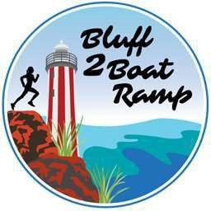

17th of February 2025 Dear Local Resident,
Everyday Lions Events with the support of the Devonport City Council will host the 2025 Bluff 2 Boat Ramp Fun Run on Sunday 16th March, at Mersey Bluff. There will be road closures or limited access around your home and or business on Sunday 16th March as per the below road closure information;

Please refer to map on the back of this letter.

On the morning of the event, we are requesting that residents and business owners refrain from parking their cars on the following roads mentioned below.

The primary roads closed are;

- BLUFF ROAD (between WILLIAM STREET and GLOUCESTER AVENUE) from 07:45 am to midday
- VICTORIA PARADE (between GLOUCESTER AVENUE and OLDAKER STREET) from 07:45 am to midday
- FORMBY ROAD (between OLDAKER STREET and WESTPORT ROAD) from 07:45 am to midday
- DEVONPORT ROAD (between WESTPORT ROAD and MERSEYSIDE STREET) from 07:45 am to midday
- FORMBY ROAD (between BEST STREET and OLDAKER STREET) from 6:45 a.m. (Start line set up)
Any Council car parks that are accessed from roads listed above will also be closed, too.
EMERGENCY SERVICES WILL HAVE ACCESS AT ALL TIMES
Timetable of Events
10 km – 8:00 am
5 km – 9:30 am
1.5 km – 10:15 am Kids 500m – 10.45 am

For further information regarding this fun run event visit www.bluff2boatramp.com

Alternatively, you can contact Taylah Swayne from Hardings Group on the day of event via the details below.

Talah Swayne – 0447 487 957

Brian Lyons/Amie Bramich Event Directors
0476 529 366

